Carillon Express

RCMP Display in Charlottetown
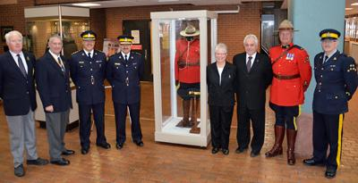
From left to right: Ernie MacAulay, PEI RCMP Veterans Association, Mike O'Neil President, PEI RCMP Veterans Association, Chief Superintendent Craig Gibson CO "L" Division, Deputy Commissioner Dan Dubeau RCMP Chief Human Resources Officer, Mrs. Betty Holmes, former ADM-SD Keith Hillier, Sgt Brad Chugg, and Squadron Sergeant-Major Larry Kavanagh.
To raise awareness of the partnership between VAC and the RCMP, a display of the iconic RCMP uniform was developed. The exhibit was unveiled on November 25, 2013, by Keith Hillier, former ADM of Service Delivery. Members of the RCMP and the RCMP Veterans Association of PEI took part in an official unveiling ceremony in the DJM Building atrium.
The display was organized by Sergeant Brad Chugg, the RCMP Liaison to VAC. Deputy Commissioner Dan Dubeau, Chief Human Resource Officer, and Chief Supt. Craig Gibson, Commanding Officer of "L" Division (PEI), represented the RCMP.
VAC offers a range of services, programs and benefits for still-serving and retired RCMP members, and their families. The exhibit is made up of items donated by Betty Holmes, widow of an RCMP officer, as well as other RCMP officers.
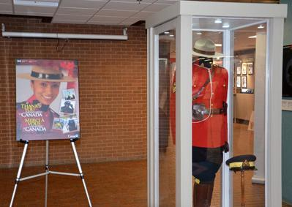
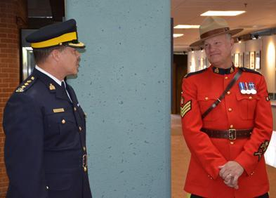
Chief Supt. Craig Gibson thanks Sgt Chugg for his work in
raising awareness to the RCMP.
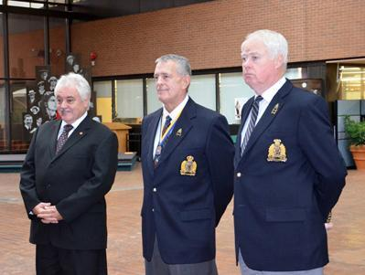
Keith Hillier with Mike O'Neil, President, PEI RCMP Veterans Association, and Ernie MacAulay, also of the PEI RCMP Veterans Association.
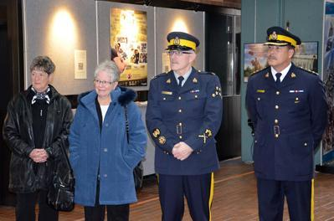
From left to right, RCMP widows Heather MacDonald and Betty Holmes,
SSM Larry Kavanagh and Chief Supt. Craig Gibson.
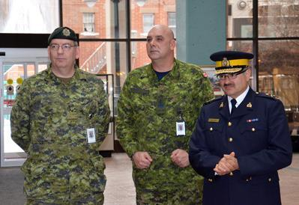
LCol Jamie Morse and CWO Darcy Elder, CAF Liaison Officers to VAC,
with Deputy Commissioner Dan Dubeau.
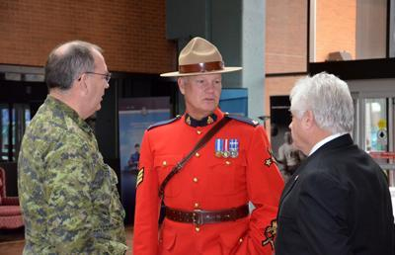
LCol Morse, Sgt Chugg and Keith Hillier following the event.
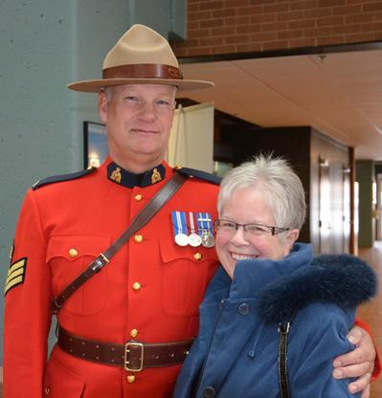
Sergeant Chugg with RCMP widow Betty Holmes who donated some
of the items exhibited.

