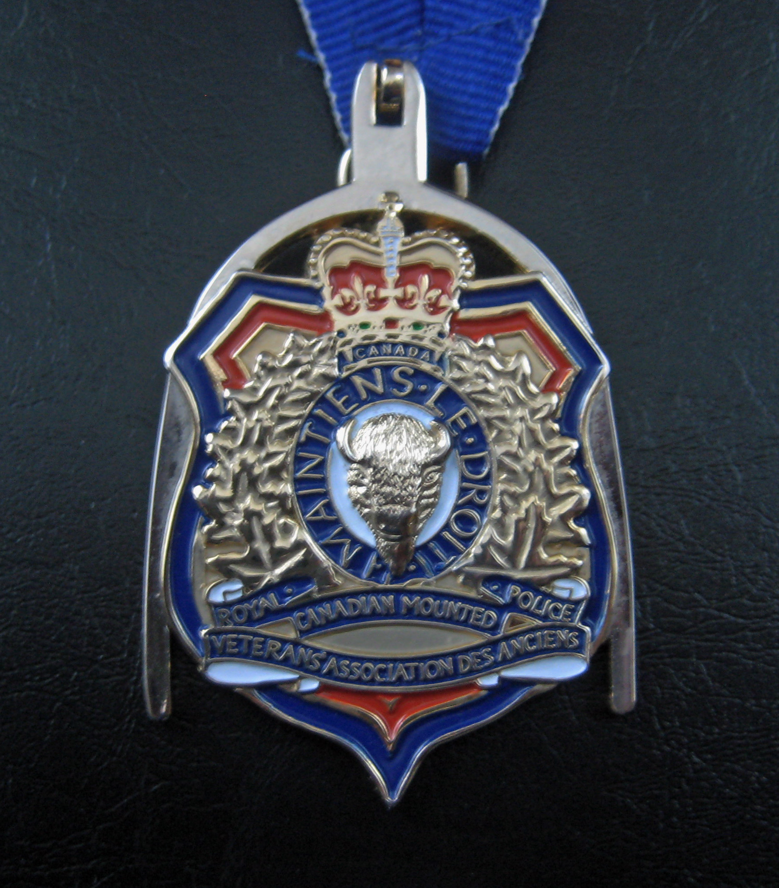

PRESIDENT’s MEDALLION

The President’s Medallion is a historical and practical representation of the heritage of the Royal Canadian Mounted Police Veterans’ Association established in April 1886.

The spur represents the formation and contribution of the North West Mounted Police, the Royal North West Mounted Police and the Royal Canadian Mounted Police in the development of western Canada.

The shield a symbol of law enforcement represents the duty of law enforcement and justice.

The thin blue line on the outer edge of the shield represents the evolving role of police service including local, Provincial, National and International service.

The scarlet and gold of the inner portion of the shield represents the colours of the Royal Canadian Mounted Police Veterans’ Association.

The crest displayed is that of the Royal Canadian Mounted Police Veterans’ Association as it appears in the Public Register of all Public Arms and Bearings in Edinburgh Scotland as of the 20 day of January l983.

