RCMP Veterans” Association
2026 Annual Meeting of Members

Our 2026 AMM was held at the Holman Grand Hotel in Charlottetown, PEI on May 22nd and 23^{rd.}, 2026. Association Presidents and representatives from Associations from Vancouver Island to Newfoundland and Labrador attended along with our National Board of Directors.

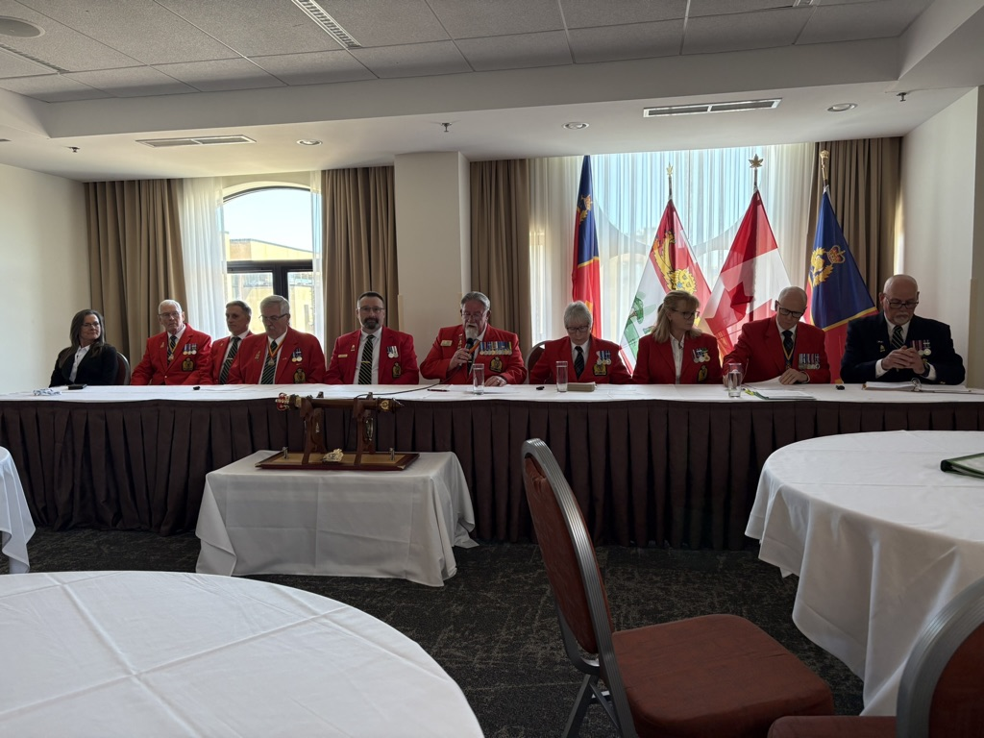

The level of engagement and cooperation were evident throughout the meetings. Updates were provided from the National Police Federation, Benefit Trust Fund, RCMP Spiritual Wellness Services and Support Team Overview. Chief Superintendent Kevin Lewis, Commanding Officer of “L” Division (PEI) was the guest speaker at the May 23rd luncheon.

The event concluded with a seafood supper celebrating the 140th Anniversary of or Veterans’ Association and the 153rd birthday of the RCMP.

While many issues were discussed from finance, common dues, to associate membership, a common theme and purpose emerged and that was to support our members and families by remaining a relevant and evolving organization.

