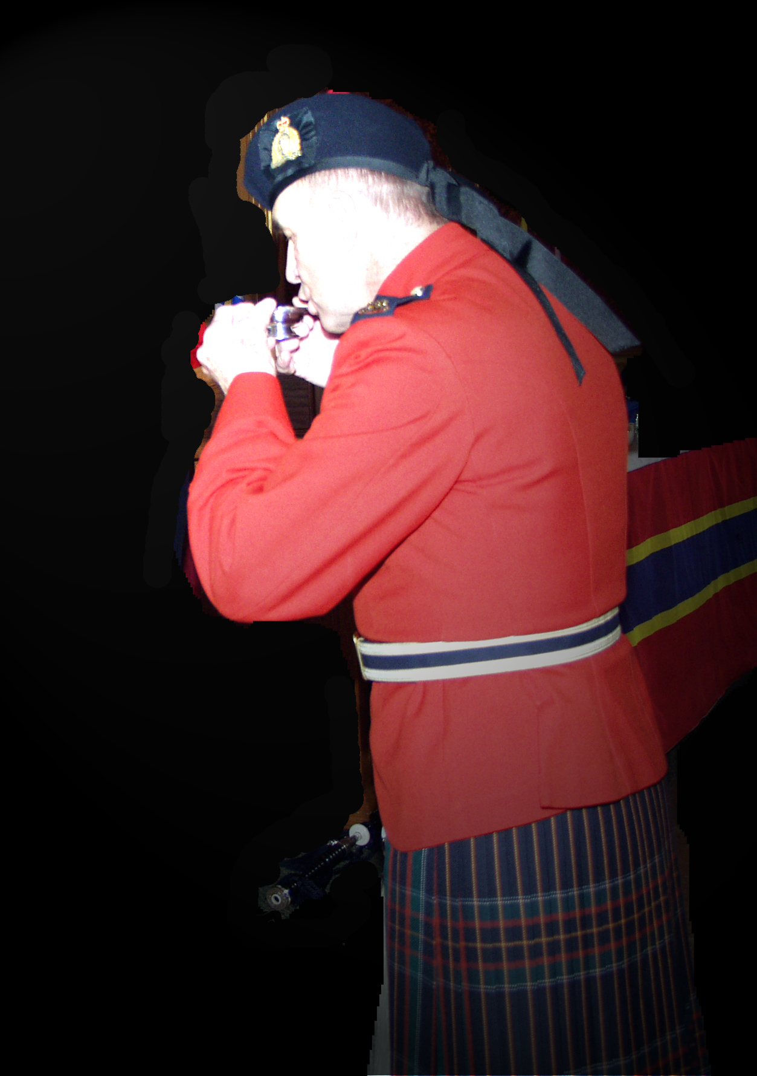
The Piper’s Toast

No explanation of “The Piper’s Toast” would be complete unless some dissertation on the origins of the Piper and the pipes was provided.

Bagpipes are a Weapon of War

“The bagpipe is the only musical instrument deemed a weapon of war because it inspired its troops to battle and instilled terror into the enemy. The skirl of the pipes stirs men's and women's souls and its power and influence in battle as in life, is measurable".
The effects of the pipes on friend or foe are legendary crossing all cultural, geographic, economic and historical barriers. An examination of the origins and development of the pipes, their use among the ancient Celts and in modern warfare and life reveal their true and enduring significance.
The origins and history of the pipes is interesting as the world has known the pipes in one form or another for more than 5,000 years. Bagpipes were invented when people found they could make music by blowing into a hollow reed and eventually the idea of harnessing a bag for a reservoir of air evolved. References to pipes are made in the Pharonic literature of Ancient Egypt, the Ancient Holy Land Scriptures. During the days of the Roman Empire there are numerous references to the pipes being played and in fact it is widely believed that Nero himself played the pipes and that Rome fell to the sound of the pipes, not the fiddle as previously thought. It is quite probable that the Romans brought the pipes to Scotland during their invasions.
The Ancient Celts called it the Great War Pipe of the North. The use of the bagpipe among the Ancient Celtic people was common. In fact, men and women were initially called to war by the harp or a bard, (Brosnachadh-Incitement to Battle) but only the first few rows of troops could hear the stirring sound so eventually it became tradition to send a piper into battle first. The Celts are recorded as being in the area of the Alps during the early centuries of the last millennium before the birth of Christ. Some of the common factors in Celtic society included a shared language, social structure and the telling of history through bards or poets, music and song. This music included the use of the pipes.
At its height, in the fifth and fourth centuries B.C., the Celtic Empire reached from the steppes of Russia to the north of Ireland. Pushed back by Roman invasion and eventually doomed at the hand of Julius Caesar, the Celtic Empire survived into medieval times only in Britain and then only in Ireland. Because the empire had been so far reaching the connection so many people feel to the Celts and their heritage is widespread. But in the northern areas of both Scotland and Ireland the Celtic ways evolved into a clan system with each chief overseeing his peoples and lands. Chiefs and Clans fought against each other piping themselves into battle by the sound of the great Highland War Pipes, eventually silenced in 1746 when the English passed a decree making the playing of the pipes punishable by death. Despite this edict, the playing of pipes continued until today.
The great Highland War pipes survived and became a symbol of Scottish Highland way of life simply because the Highlanders continued to use them when other countries did not. "Over the last two hundred years and more, the Highland regiments of the British Army have played a vital part in keeping alive clan feeling and the Highland tradition, reflecting a sense of special spirit." The Highlanders' use of the great bagpipe seems to have developed in its current form in the 16th century. The clans were growing and required more sound than a harp could make. The MacCrimmon's, the hereditary pipers of the Isle of Skye are credited with evolving "big Music" or Piobaireachd music, the classical music of the bagpipes. The MacCrimmons are the hereditary pipers of the Macleods for 13 generations.
There is a museum on the Isle of Skye created by Irene and Hugh MacCrimmon who currently live in Guelph, Ontario. The museum also reflects Highland life. Dunvegan, Skye remains today the place of renowned piping all over the world. Legend claims that the fairy Queen assured the first MacCrimmon that he would play the finest music in the world. And he did! The playing of the air is followed by a number of variations according to strict rules of composition and the music is very elaborate and stylized. The themes mainly consist of Laments, Gatherings and Salutes. This was the form of piping played to the 19th century. Although for relaxation, pipers might play a lighter composition and it was considered derogatory to play for dancing. Every chief and royal house had its pipers. The music of the pipes underwent great change in the 19th century with competitions and reels, strathspeys, tunes, slow marches and drum sections of battalions being replaced by pipes.
In the early 1700's the English and Scottish were fighting over control of land and people. It was an age-old battle with many complications. In the Highlands of Scotland, there were many separate clans, each with a chief, each thinking they had a right to the crown. They fought among themselves and for nearly 1000 years against the English. In 1746 all the fighting came to an end. In the Battle of Culloden the Highland clans met the gunfire of the English and were wiped out on Drummoisse Moore. The Highland way of life was destroyed and the Act of Proscription was put in place. This act forbade the wearing of Tartan, the speaking of Gaelic, and the playing of the bagpipes. It was at this time the pipes were declared a weapon of war and pipers were actually drawn, quartered and hung for playing the pipes. The English swept through the Highlands like ants at a picnic destroying pipes and burning the piper's huts. Many people were thrown in jails and many were sold as slaves. If a person were caught playing the pipes or breaking any aspect of the Act of Proscription, it meant lashes with the cat of nine tails and then imprisonment or worse, death.
It wasn't until the English began to raise regiments and put them in kilts and encouraged the playing of the pipes that this changed. Proscription was in place for 50 years. Thus it can be said that playing the pipes is about survival, tenacity and rising up against injustice - a music that reaches the soul and lingers in the mind long after the drones are put to rest. By the 1800's numerous Highland regiments had been raised in the British Isles and in North America and pipes were playing an important part of both American and Canadian history. The pipes were there at the capture of Quebec, Ticonderoga and the siege of the Alamo. There are actually references to Davie Crockett being heartened by the piping of John MacGregor. The pipes were in Nepal, the Boer War, and both World Wars with the Germans referring to the pipers as "Ladies from Hell".
In W.W.I., the pipers went up over the top of the trenches piping their men into war across no-man's land, land mines, barbed wire and enemy fire. Pipers couldn't play and carry a weapon so they were sitting ducks in modern warfare and many died in both world wars. Over 1,000 pipers died in W.W.I. The last surviving piper from W.W.I is Harry Lunan. He describes his piping experiences in the war as an honour. "You were scared, but you just had to do it, they were depending on you." Despite poisonous gas, guns, barbed wire, land mines and the general horror of war, pipers piped their men into battle as they had done three thousand years earlier. The effect was the same. It encouraged the men and left the enemy in shock that someone would be brave enough to play the pipes in the middle of trench warfare. The same thing happened in W.W. II. More recently, pipers also played a role in the Gulf War and Desert Storm operations. The effect was the same. It takes a great deal of know how and concentration to pipe under such circumstances and the piper had to be well seasoned.
The bagpipe is deemed a weapon of war because it inspired its troops to battle and instilled terror into the enemy. The skirl of the pipes stirs souls. The effects of the pipes are legendary crossing all cultural, geographic, economic and historical barriers. From the origins and development of the pipes, their use among the ancient Celts and in modern warfare and life reveal their true and enduring significance which continues to be passed down from generation to generation in current times.”

The Difference of Burgh & Clan Pipers

In pre-Reformation days there was a “burgh piper” who was a man of peace (a.k.a. “town minstrel”) and a “clan piper” who was a man of war. The clan piper belonged to the clan chief who often entertained after dinner. During the festivities the clan piper was invited into the dining hall to have a dram with the clan chief. In so doing, the clan piper would propose a toast to which the clan chief would reply.

The Clan Piper’s Toast

The toast is of extreme significance since not only does it have its origins in ancient history but it symbolizes the status of the piper and relationship with the clan chief or, in modern times in Canada, with the Commanding Officer.

When a piper has been arranged for a mess dinner, the procedures are as follows:

- The Event Organizer should ensure that a room is allocated for the piper to use as a tuning / dressing room. This room should be located far enough from the guests so that the piper will not be heard while he / she is tuning. It is recommended that they be not too far, therefore allowing for easy communication.

- In setting up the dining room a clear aisle/passage must be left around the perimeter to permit the piper to march freely while they play.

Routine

- Alert(s) - at fifteen and five minutes prior to the scheduled time for dinner, the piper should position himself at a predetermined spot and at the halt; play a short tune as a “warning for dinner”. When finished playing, he / she should move to his / her position ready to play the march in to dinner.

- March In - On cue from the Master of Ceremonies, the piper leads the head table procession into the dining room playing an appropriate tune, and marches counter clockwise around the perimeter so that his or her drones will not collide with or be caught up on anything.

- On completion of one circuit of the room, the piper should continue playing, at the halt, near the doorway until all Head Table Guests have reached their assigned seating, or upon direction from the Master of Ceremonies.

- The piper should remain at attention until “Grace” and “Recognition of Fallen Comrades” has been said. The Piper may retreat to a less obvious position within the dining room.

- No toast should take precedence over the Loyal Toast to the Queen. If the Piper is remaining for the dinner, the Piper’s Toast should be honoured following the Loyal Toast. If the Piper is not remaining for the dinner, it would be inconsiderate to have the Piper remain for a lengthy period after they have played merely to participate in the Piper’s toast.

The Toast

- When the Piper’s Toast is to be held, the Master of Ceremonies (Mess Sergeant) carrying a salver bearing two quaiches (containing a dram of whisky / scotch each) will lead the Piper to the right arm of the Commanding Officer. When the Commanding Officer rises, the Piper will salute the Commanding Officer. The CO will take a Quaich and hand it to the Piper. (The senior guest may be invited to do this, if appropriate).

- The Piper holds the Quaich, at about chin level, and gives the Toast "SLAINTE" pronounced “Slawn cha” meaning "Good health".

- The Commanding Officer replies: "SLAINTE MHATH" pronounced “Slawn cha vha”, meaning "Good health to you"

- The CO and the Piper then drain the contents of their Quaich in one drink / draught, turn it over and kiss the bottom of the Quaich to indicate that is has been entirely drained. The quaiches are then returned to the salver.

- The Piper salutes, if required, and asks the Commanding Officer for permission to “pipe out”. Upon receiving permission, the piper continues his/her counter-clockwise march around the dining room, and plays an appropriate tune whilst marching out of the dining area.

- All dinner guests must be aware of the significance of the Piper’s Toast and there must be absolute silence during all portions of the Toast.

From “Canada At War” website: http://wwii.ca/forums/showthread.php?t=729
“…historians refer to the town pipers as minstrels, a term which continues the tradition that goes back to the days following the Norman invasion, and invests the piper with the dignity of a very ancient office. So we find the term minstrel used time and again of the burgh piper…” The bagpipe: the history of a musical instrument, by Francis M. Collinson, p.100.

