“Passing the Port”

A Little About Port Wine

“Port wine, also known as Vinho do Porto, Porto, and often simply Port, is a Portuguese style of fortified wine originating from the Douro Valley in the northern provinces of Portugal. It is typically a sweet red wine, often served as a dessert wine, and also comes in dry, semi-dry and white varieties. Fortified wines in the style of port are also produced outside of Portugal, most notably in Australia, South Africa, Canada, India, Argentina and the United States. Under European Union guidelines, only the product from Portugal may be labeled as Port. Elsewhere, the situation is more complicated: wines labelled "Port" may come from anywhere in the world, while the names "Dao", "Oporto", "Porto", and "Vinho do Porto" have been recognized as foreign, non-generic names for wines originating in Portugal.
Port is produced from grapes grown and processed in the demarcated Douro region. The wine produced is then fortified by the addition of a neutral grape spirit known as Aguardente in order to stop the fermentation, leaving residual sugar in the wine, and to boost the alcohol content. The fortification spirit is sometimes referred to as Brandy but it bears little resemblance to commercial Brandies. The wine is then stored and aged, often in barrels stored in "caves" (pronounced "ka-vess" and meaning "cellars" in Portuguese) as is the case in Vila Nova de Gaia, before being bottled. The wine received its name, "Port", in the latter half of the 17th century from the seaport city of Porto at the mouth of the Douro River, where much of the product was brought to market or for export to other countries in Europe. The Douro valley where Port wine is produced was defined and established as a protected region, or appellation in 1756 - making it the third oldest defined and protected wine region in the world after Chianti (1716) and Tokaj (1730).”
Origins
More legends and traditions have been forged with regard to Port wine, probably more than any other wine. Most of these come from the English, who learned to appreciate this wine centuries ago.
The tradition of the toasts or drinking to health comes down to us from ancient times. Greeks and Romans drank to their Gods and beverages were poured to honour the ladies. In the course of time, “good health” became an expression of greeting. The words “toast” dates from the closing years of the Tudor period and originally associated with the custom of drinking to the ladies. A bit of toast was placed in the wine in the belief that it improved the flavour. To this day the toast remains one of the most cherished customs of mess life.

In addition to the Loyal Toast, depending on the circumstances and tradition, there may be other toasts at a mess dinner, including those proposed to: foreign heads of state (dignitaries) when their official representatives are present; “fallen comrades”; the Force and others.

Passing the Port
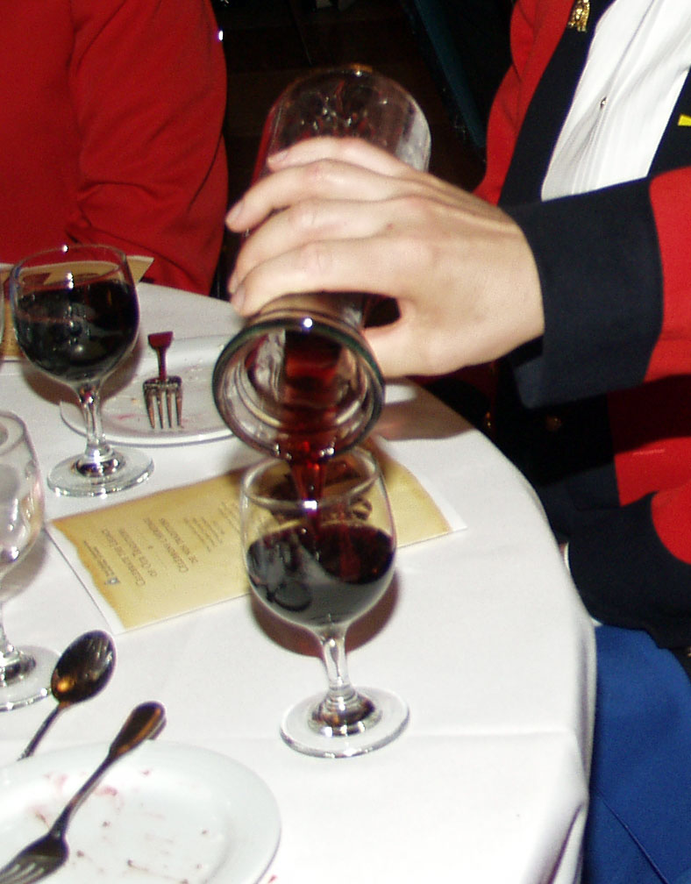
Port Wine is traditionally served and passed from right to left. This tradition is known as “passing the port,” and its origin attributed to officers in the English Navy. One of the explanations of this is that it was seen as sign of friendship and peace to the person sitting on your left. Pouring a glass of Port with your right hand would prevent you being able to draw your sword or revolver. A more practical reason is that the majority of people is right-handed making it easier to pour the wine with the right hand and pass on with the left.
While holding the decanter in front of him, the host would serve his guest on his right and pass it to the guest on his left, and it would be passed on down until it returned to the host.

In Port Wine tradition, it is bad etiquette to ask to pass decanter; as such, the host should ask the guest seated closest to the decanter if he knows the bishop of Norwich. This is aimed not at obtaining a reply, but, rather, an immediate action, that the wine be passed to him. Still, if this does not occur, and the reply is “No,” that guest should be told that “The bishop is an excellent companion, but never passes the Port.” If a guest passes the Port incorrectly, he might be told that his “passport is out of order”.
Using a decanter with a rounded bottom can prevent the problem of not passing the Port. The Port then has to be passed around until the bottle is empty or at the most can be put in a holder in front of the host.
Although it is acknowledged that most of these habits are no longer observed, it is always interesting to recall a few of these, especially when Port Wine is being served.
The Ceremony
After the last course, the tables are cleared, except for the port glasses, centre piece trophies, candelabra and floral arrangements, if any. A single decanter of port is placed on the table in front of the Senior Officer. If the gathering is large, wait staff will position themselves at strategic locations with additional decanters to be placed around the dining room following the service of the Senior Officer and his Guest.
The Senior Officer removes the stopper from the decanter, pours a half glass to the guest on their right, charges their glass half full, and passes the port to the person seated on their left. Once the passing begins, the other decanters are now placed, without stoppers, in front of other nominated members, who fill their own glasses and pass the port to the left. As each subsequent diner receives the decanter, they charge their glass half full and pass the port “outside the glass” to the next diner on the left who takes it without allowing the decanter to rest on the table.
During the first passing of the port, which is in preparation of the Loyal Toast, it is customary in the ground and air forces to ensure that the decanters do not touch the table until all glasses have been filled. This action symbolizes a toast and the chain of unbroken loyalty to the Sovereign and therefore nothing should come between a member and the Sovereign.
The custom in the marine forces is that the decanted never leaves contact with the tabletop, which requires the glass to be lower than the tabletop during the pour. Where this is not possible, the port decanter is lifted to pour, the decanter remains in contact with the glass rim throughout the pour and the glass remains on the table. This originated from the need at sea to keep the decanter steady at all times.
Silence is observed during the passing of the port as a mark of respect to departed comrades.
In the case of ladies being at the dinner, the gentlemanly act of pouring for the lady on the left should occur, after which the pourer passes the decanter to the next member on the left of the lady.
As the decanters pass around the tables, stewards / wait staff follow to replace empty decanters or to serve iced water to those who do not wish to drink port. When all have been served, the wait staff, except for the Maitre d’, withdraw for the duration of the toast(s), after which they return to replenish the decanters and assist with further passing of the port, if required.
The Second Passing of the Port
After a short interval the Commanding Officer may decide to circulate the port decanters again but during this and subsequent circulation, silence is not a requirement and the decanters may touch the tables and remain unstoppered. Whilst the second circulation of the port is in progress the Master of Ceremonies rises and welcomes and introduces the official guests. The Master of Ceremonies, or designate, may, at this time invite the guest speaker to address the membership.

Taken from Wikipedia [http://en.wikipedia.org/wiki/Main_Page] in a query of “Port Wine”
This refers to Henry Bathurst, 1744-1837, Bishop of Norwich from 1805-1837, who in his nineties used to fall asleep and fail to pass the port.

