Introduction

The following guidelines are presented for the information of the members of the RCMP Veterans’ Association, Prince Edward Island Division. The material has been adapted from various websites of other Veteran Divisions and the National Association, and with the assistance of “L” Division personnel, from the RCMP Uniform and Dress Manual.

Contents

- These guidelines describe the recommended dress for Members of the RCMP Veterans’ Association, PEI Division.

- The organizer of every function will determine the appropriate Order of Dress for that occasion, and will confirm the selection of the order of dress with the Executive Director of the PEI Division, who in turn will advise the membership.

- If the event being attended is with serving members, and the Division Sergeant Major has been assigned responsibility for their coordination of that parade, discipline and so on, the Executive Director will ensure decisions concerning the Order of Dress are coordinated with the Sergeant Major.

- There are three orders of dress for Veterans: (a) working dress: worn while attending business meetings, luncheons, and representing the Veterans’ Association, not of a formal nature; (b) walking-out dress: all parades and honour guard appearances; and (c) formal dress: regimental / formal dinners and balls.

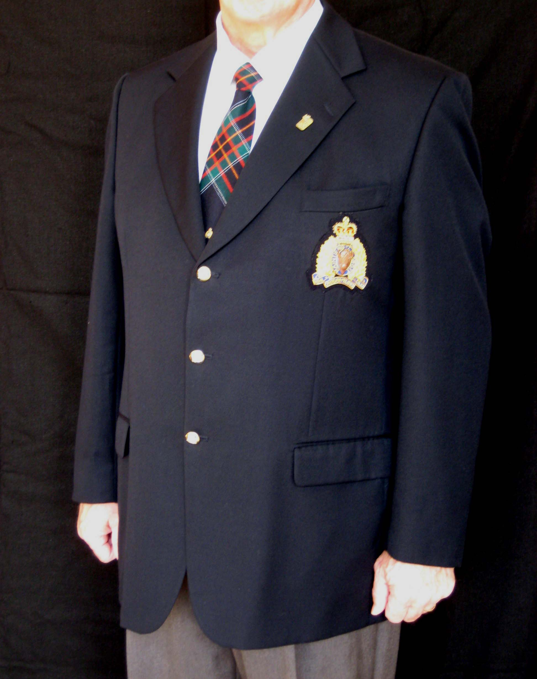
  - Order No. 1 - Working Dress

    - Blue Blazer

      - Male members will wear a navy blue, single-breasted blazer with a left breast pocket, standard lapels and square side pockets with flap. Female members will wear a navy blue, single-breasted blazer with a left breast pocket, notched collar and narrow lapels, and slash side pockets. The length of the blazer should reach the hip, but not go any lower;
(Under Construction)

      - The RCMP Veterans’ Association crest is placed on the left breast pocket;

      - Two large gold RCMP buttons are worn on the front of the blazer and two small gold RCMP buttons on each of the sleeves.

    - Other Items of Clothing

      - Male members are to wear a white dress shirt with regimental or RCMP tartan tie. Female members are to wear a white blouse type shirt. Ties are optional for female members;

      - Male members are to wear dark grey pants. Female members are to wear either dark grey pants or dark grey skirt;

      - Male members are to wear black dress shoes, while female members are to wear black low heel or flat heel dress shoes...

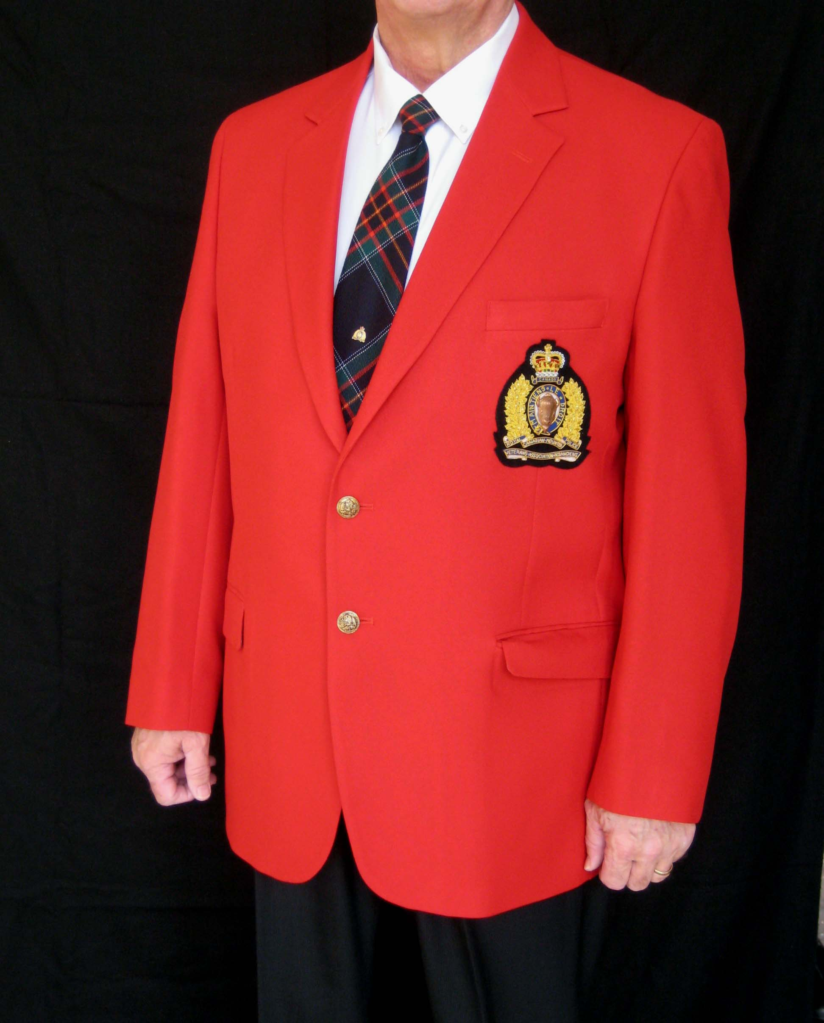
  - Order No. 2 - Walking Out Dress

    - As per Order No. 1 - Working Dress, however, the colour of the blazer changes to the same colour of red as found in the RCMP red serge.

    - The dark grey pants or skirt are replaced by navy blue pants or skirt.

    - A Veteran, not in possession of a red blazer, may participate in the event by wearing their blue blazer, accompanied by dark grey pants or skirt.
(Under Construction)
  - Order No. 3 - Formal Dress

    - As per Order No. 2 – Walking Out Dress, with the following exceptions:

      - Male and female members are to wear a dress shirt and black bow tie.

      - Retired Officers are to wear the navy blue vest under their red blazer.

      - A Veteran, not in possession of a red blazer, may participate in the event by wearing their blue blazer, accompanied by dark navy pants or skirt.

      - Male members may wear tuxedo trousers. Female members may wear a black floor length skirt.

- The following guidelines are to be read in conjunction with the above Orders of Dress.

  - Headdress

    - The wedge cap will be worn for parades and other events, when requested by the member organizing the event. If a member does not have a wedge cap, no headdress should be worn.

      - The cap should be worn at a slight angle to the right. The Veterans’ cap badge is worn on the left side, positioned near the front of the cap.

    - Veterans who have served on a United Nations Mission and awarded the UN Medal, may wear the blue beret if attending Peacekeeping Day ceremonies or other UN designated functions.

      - The beret should be worn evenly on your head with the sweatband 2.5 cm above the eyebrows and the crown pulled down to the right. The break of the sweatband should be centered at the back of the head with no draw string visible.

    - When removing headdress, wedge cap or beret, remove it with your right hand. Place the brim of the hat under your upper left arm with the back to the rear. Keep your left elbow at your side. Bend your left forearm to an angle of ninety degrees. Rest your cap along your forearm and curl your fingers slightly over the front of the cap.

  - Medals

    - If a member does not have miniature medals, the member will not be expected to purchase them. Miniature medals will be worn only with the formal order of dress.

    - Large medals will be worn on the left breast with the bottom of the medals 1/4 of an inch above pocket line and centered over the crest. Large medals are worn for all functions, except for informal occasions, (working dress); and when the order of dress is formal.

    - Miniature medals are to be centered on the left lapel bottom of medals approximately ¼ of an inch above the top line of the breast pocket.

    - Service medals only to be worn on left breast.

    - Other Medals (e.g.: Royal Humane Society, Royal Canadian Legion) are to be worn on the right breast.

  - Undress Ribbons

    - Wear undress ribbons centered 4.0 mm above the left breast pocket of the red or blue blazer in the same order and on the same side as medals are worn.

    - When a large number of ribbons are worn, place one row above the other, with the shortest row centered on the top.

    - Centre ribbons over the pocket but do not extend them beyond the pocket.

  - Emblems

    - Mourning Ribbon

      - The black and blue looped mourning ribbon, pinned at the center with a pewter maple leaf badge, is the national symbol for mourning peace officers who have died in the line of duty;

      - The ribbon may be worn during the official mourning period, at a peace officer funeral or commemorative service. The official mourning period is the period from lowering the flag to raising the flag;

      - The ribbon is worn on the top portion of the left breast pocket, positioned close to the heart, on either the blue or red blazer; and

      - The ribbon is not to be worn to replace the poppy on Remembrance Day.

    - Maple Leaf

      - The Maple Leaf emblem should only be worn on Canada Day.

      - If headdress is worn, the emblem is placed on the left side of the headdress. If no headdress is worn, the emblem should be positioned on the left lapel above the medals or above the place where the medals would be worn of either the red or blue blazer.

    - Poppies
      - If headdress is worn, poppies should be worn on the left side of headdress. If no headdress is worn, the emblem should be positioned on the left lapel above the medals or above the place where the medals would be worn of either the red or blue blazer.

- RCMP Regulations, Section 68, permits the Commissioner of the Royal Canadian Mounted Police to authorize members who retire or are medically discharged to continue to wear the RCMP uniform on state and official occasions.

  - Section 68 of the Regulations does not provide retroactivity; therefore, members who retired before 1988-06-30 are not authorized to wear the uniform.

  - More information can be found in the RCMP Uniform and Dress Manual, Section K.

National Office, Vancouver, Vancouver, BC, Calgary, AB and Newfoundland and Labrador
C/Supt. R. Robar, S/S/M L. Kavanagh, “L” Division
Valid as of 2009-11-12

