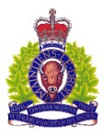[](https://www1.johnson.ca/savings)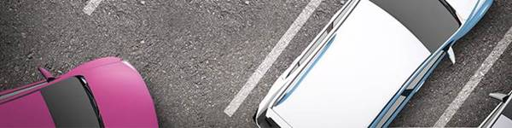

**SAVINGS RESERVED JUST FOR YOU.**

Johnson Insurance, the preferred insurance provider for Prince Edward Island RCMP Veterans’ Association, have reserved **exclusive savings of up to 30% on auto insurance\*** for you.

As many of our members already know, Johnson puts Prince Edward Island RCMP Veterans’ Association members first. Along with great savings, you get AIR MILES Reward MilesⓇ±, 24/7 claims handling and first auto claim forgiveness.

Plus, with the Homeowners Comprehensive policy, members can now benefit from over 30 new and improved home insurance coverages.

Call Johnson for a home and auto quote and see what they can do for you.

**1-877-217-5833**

Sincerely,  
  
Michael O'Neil, President  
RCMP Veterans' Association,  
Prince Edward Island

Mention Group Code **ZY** for your preferred rates.

### Visit [Johnson.ca/savings](https://www1.johnson.ca/savings)