Commanding Officer “L” Division (PEI)

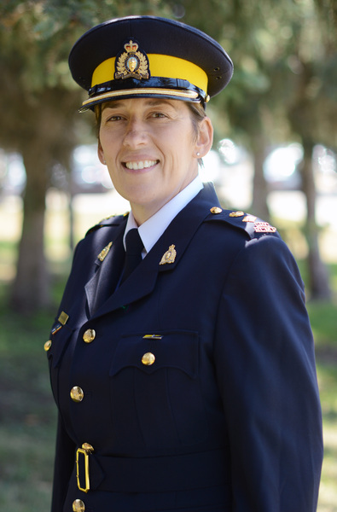
Chief Superintendent (C/Supt.) Ebert was born and raised in London Ontario and joined the Royal Canadian Mounted Police in 1997 and was posted to Northwest Territories (G Division), Nunavut (V Division) and Alberta (K Division), and most recently Saskatchewan (F Division), respectfully before being named as the Commanding Officer of Prince Edward Island (L Division).

While in "V" Division she was given a Commanding Officer's Commendation for her actions in a Member involved shooting.

In K Division, she was posted to Hinton Detachment in General Duties, Edson Provincial GIS, promoted to the Major Crime Unit in Edmonton (1998), and promoted to Wood Buffalo Detachment in 2011 as a Team Leader of Serious Crimes and Domestic Violence Units. While at Wood Buffalo, she was designated as an Accredited Team Commander. During her final two years at Wood Buffalo, she managed the Professional Standards and Administrative office and received the Queen's Jubilee Medal.
In 2014, C/Supt. Ebert became the Officer in Charge of the Major Crimes Branch in Saskatchewan (F Division), during 2016 she was also the Acting South District Commander for a period of seven months. C/Supt. Ebert has extensive background in Major Crimes including homicides, crimes against persons and sensitive investigations and was promoted to Superintendent in January 2017, in the role of OIC Major Crimes.
In the summer of 2017 C/Supt. Ebert was appointed as the Commanding Officer for the province of Prince Edward Island.
A political science major in University, C/Supt. Ebert holds an Honours Bachelor of Arts degree from Lakehead University, a Police Leadership Certificate from Dalhousie University, and a Professional Leadership Certificate from the University of Regina.
Dedicated to healthy life style and comradery of fellow police officers, C/Supt Ebert has been involved in the Baker to Vegas Law enforcement Challenge Cup Relay since 2009, participating on the K Division's Women's Team as part of the "35 years of Women in the RCMP" celebrations as a runner and later as a Team Captain. C/Supt. Ebert, her husband and their youngest child will live just outside of Charlottetown in Stratford and look forward to being part of the community enjoying the beaches, food and culture of the Island.

Date modified: 2017-10-26

